**Assumptions:**

* You already have a GitHub account -> [www.github.com](http://www.github.com)
* You can run terminal(Command prompt) as “Super user”
* If you’re Mac user, you already have Homebrew. -> <https://brew.sh/index_es>

**For a fresh and upgradeable version of VariaMos Web (Back-End) we need to follow these stages:**

1. Download Eclipse EE (It must be an "Enterprise Edition" to enable server configuration)
2. Download apache Tomcat 8.5 (Latest verified and compatible version with VARIAMOS-SERVICES)
3. Forking the project and cloning it into your local machine with GitHub.
4. Import Maven Project with Eclipse EE
5. Configure Tomcat in Eclipse EE and run the server at localhost in the port 8080.
   1. Change the ports used by Apache Tomcat v8.5 (8081 for example)
6. Set up VariaMos-Services in VariaMos-Web

**Stage 1 - Download Eclipse EE**

*Eclipse is an integrated development environment (IDE) used in computer programming, and is the most widely used Java IDE -* [*Eclipse - Wikipedia*](https://en.wikipedia.org/wiki/Eclipse_(software))

* Download from the following site:

<https://www.eclipse.org/downloads/packages/> (Choose your operating system)

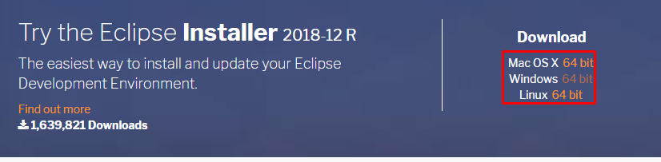

For Windows -> Unzip in your preferred folder

For Mac -> “Mount” DMG file.

For Linux -> Unzip in your preferred folder

**Note:** If you already have eclipse, make sure it is an Enterprise Edition, since you need it for server configuration.

* Click on ***eclipse.exe*** or your **eclipse executable** and select a folder as your workspace (You will save Eclipse projects data there) (In Windows by default it is “*C:/Users/{User}/Eclipse”)*

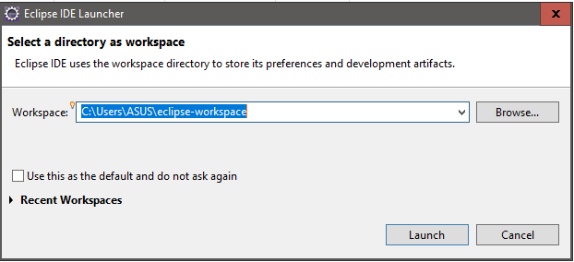

**Stage 2 - Download apache Tomcat 8.5 (Latest verified and compatible version with VARIAMOS-SERVICES)**

*The Apache Tomcat® software is an open source implementation of the Java Servlet, JavaServer Pages, Java Expression Language and Java WebSocket technologies. The Java Servlet, JavaServer Pages, Java Expression Language and Java WebSocket specifications are developed under the Java Community Process. -* [*Apache Tomcat Official Site*](http://tomcat.apache.org/)

* Download from the following site:

<https://tomcat.apache.org/download-80.cgi#8.5.37>

* If you’re Windows user, download 32/64 bits Zips, Mac and Linux tar.gz file.

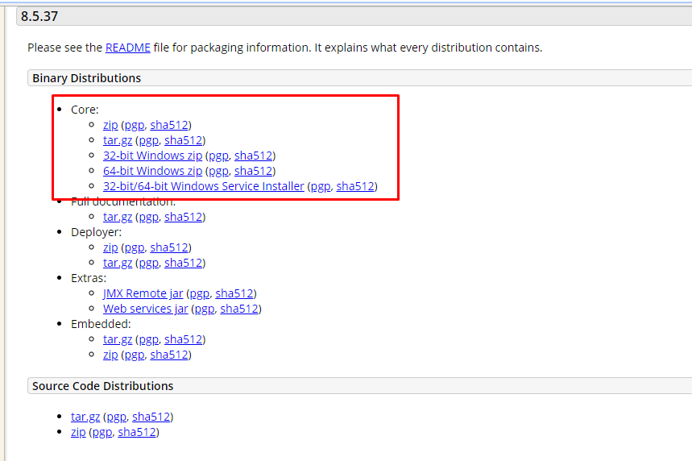

* Once downloaded, unzip the folder and check the integrity of the download.
* Normally you can find the executable in your download **“/bin”** folder, in Windows its named as **“Tomcat8w.exe”**

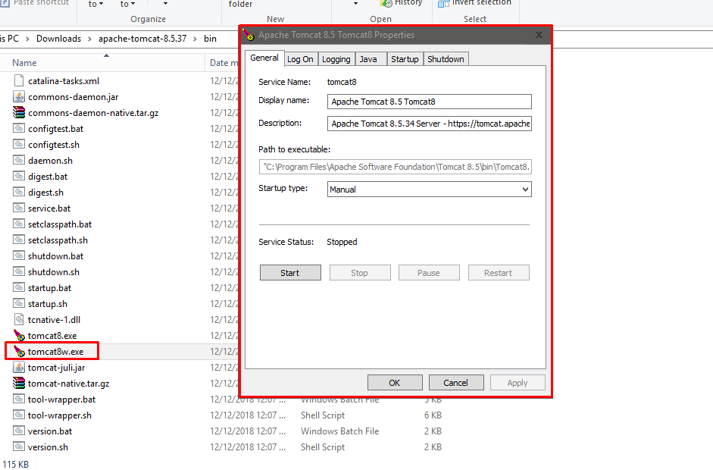

* If you haven’t set your JAVA_HOME environmental variable, you can look the following guide focused in Tomcat for Windows. <https://www.wikihow.com/Install-Tomcat-on-Windows-7>

**Stage 3 - Forking the project and cloning it into your local machine.**

* Go to the following site: <https://github.com/SPLA/VARIAMOS-SERVICES>
* (Login if you aren’t logged in) Click in Fork 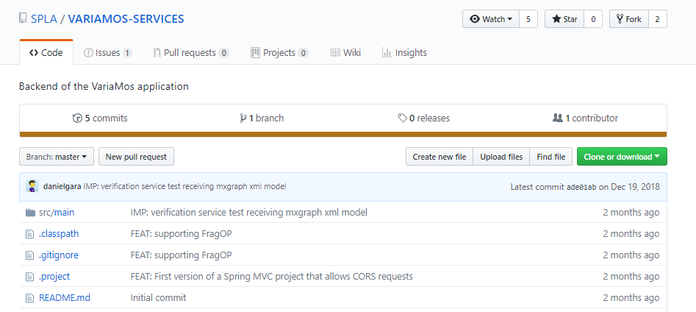
* If everything was ok, you should see instead of SPLA/VARIAMOS-SERVICES -> {your-username}/VARIAMOS-SERVICES

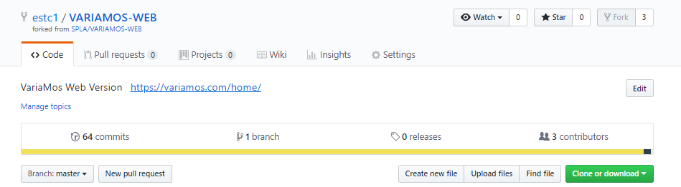

* Click in Clone or download and copy the URI clicking in the button highlighted in red in the image above.

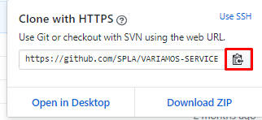

* Open Command prompt and get to the folder where you want to clone the project.
* Write the following code modifying the text in the curly brackets for your clipboard

git clone {your fork URI}

* To verify if it was correctly installed compare the output messages and should be similar to the image above:

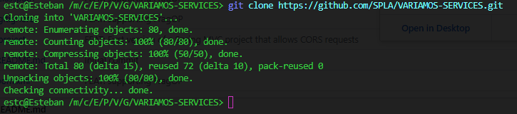

**Setting up the upstream repository (Sync your local fork with the original repository)**

* List the current configured remote repository for your fork with the following command:.

git remote -v

You should see something like this:

origin https://github.com/*YOUR_USERNAME*/*VARIAMOS-SERVICES*.git (fetch)  
origin https://github.com/*YOUR_USERNAME*/*VARIAMOS-SERVICES*.git (push)

* Specify the original repository to sync with your fork with the following command:

git remote add upstream https://github.com/SPLA/VARIAMOS-SERVICES.git

* Verify original repo was added in remote repository in your fork with the following command:

git remote -v

You should see something similar to the image above:

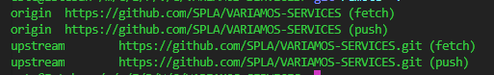

**Stage 4 - Import the project as Maven Project in Eclipse EE**

* Open Eclipse EE in your workspace and click in **“File - Import”**

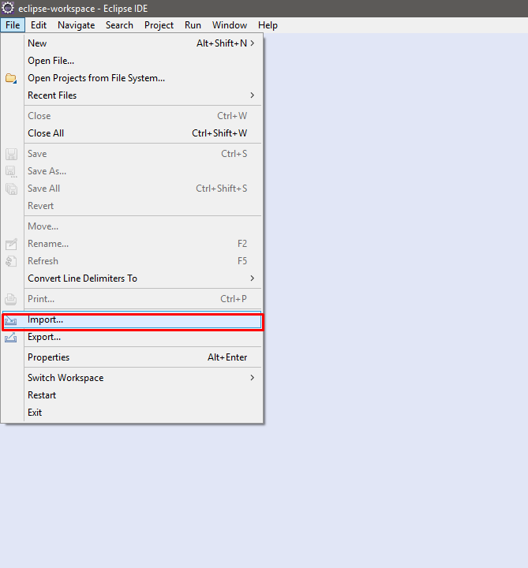

* Search for **“Maven”**, expand it and click in **“Existing Maven Projects”** as the following image.

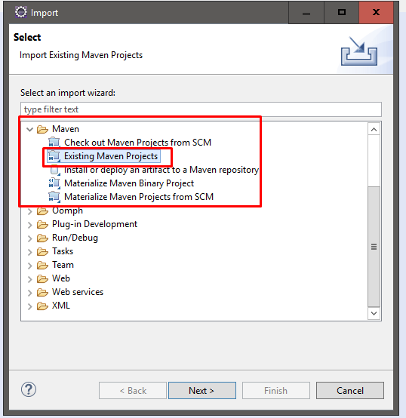

* Click in next, and browse your folder with VARIAMOS-SERVICES

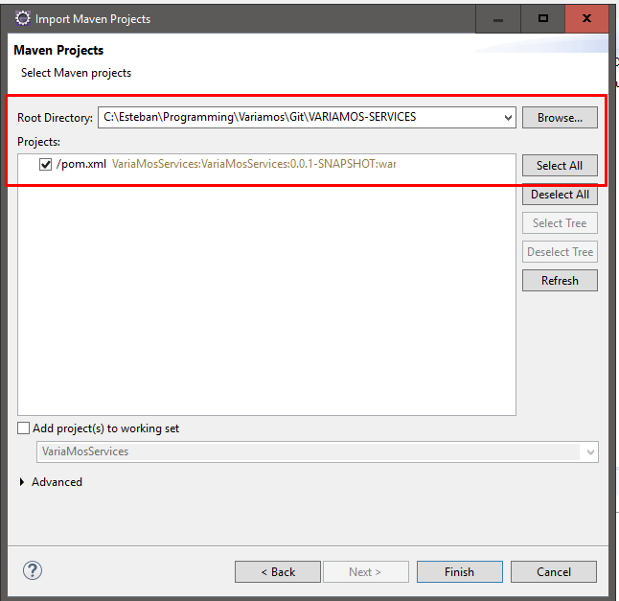

* Check “**pom.xml”** and finish import. In your project explorer you should see something like this:

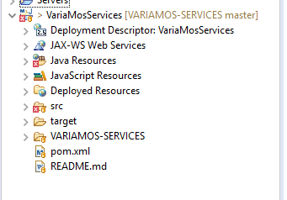

**Stage 5 - Run Variamos-Services and configure Tomcat.**

**Tomcat configuration:**

* Click in **“Windows - Preferences”**

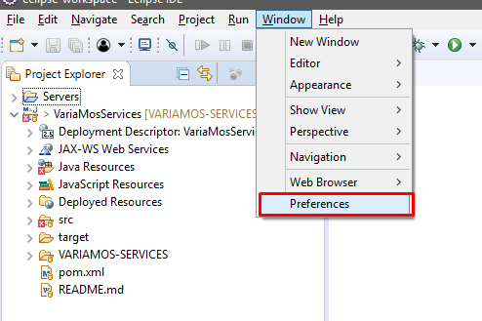

* Write **“Server”** in search box and click in **“Runtime environments”**

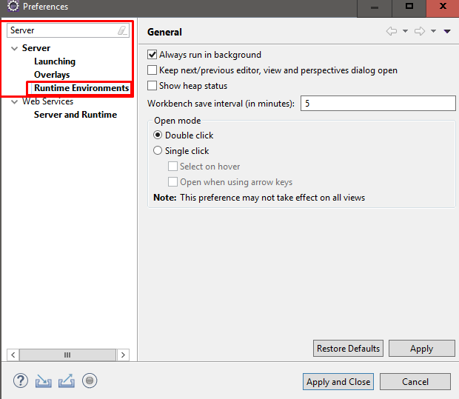

* Click in **“Add”**

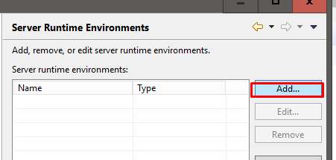

* Search for **“Apache”**, expand and select **“Apache Tomcat 8.5”**

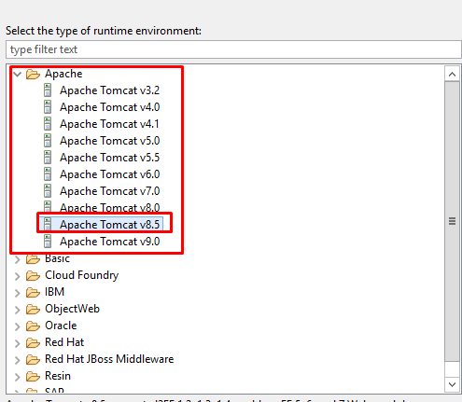

* Verify Tomcat was correctly added and click in **“Apply and Close”**

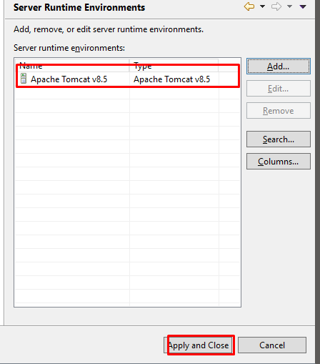

* Left click on project, expand **“Run as”** and click **“Run on server”**

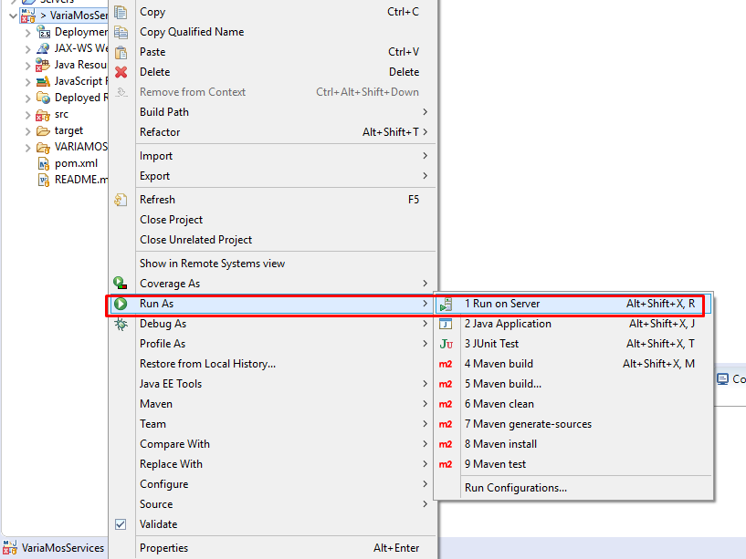

* Search for **“Tomcat v8.5 Server”**, define hostname,server name and select runtime environment(Tomcat v8.5) and click in “**Finish”**

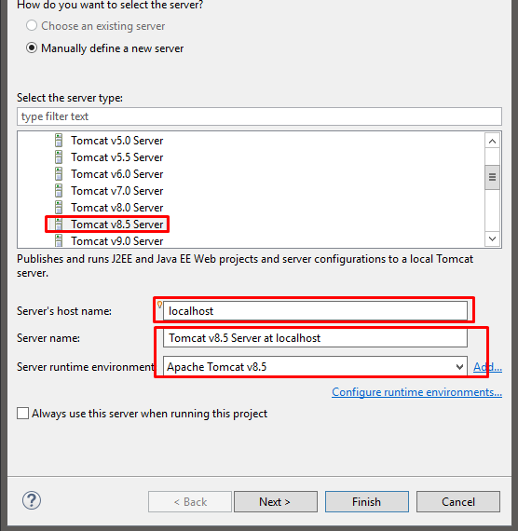

* If everything was OK you should see the following:

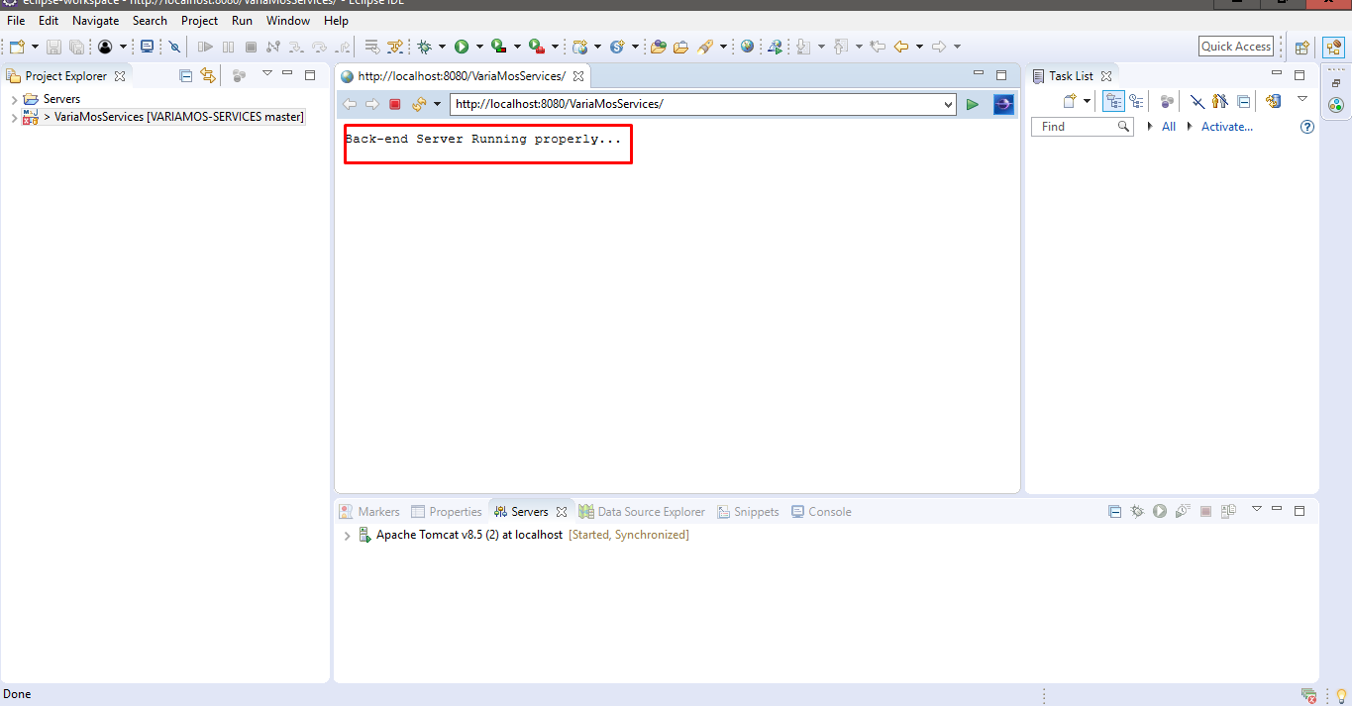



**Changing Apache Tomcat v8.5 ports:** if you get an error telling you that port 8080 or some other port is already in use you can change the ports which Tomcat listens to.

* Click on “**Servers**”, double click on the server you want to change the port, it will open a window where you can change the ports numbers.



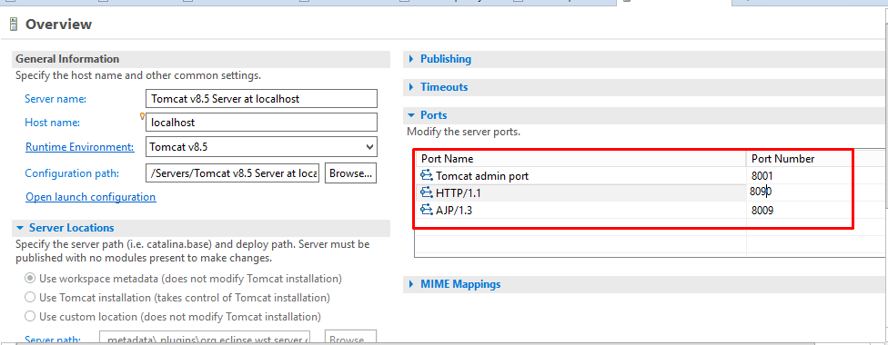

* **Change the port for whatever you want (A valid port)**
* All you have to do left is **save** **the changes,** execute the serverand you will get the following results showing how Variamos-Services is running on port 8081:

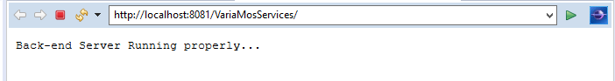

**Stage 6 - Set up VariaMos-Services and VariaMos-Web.**

* We have to make sure we are using Java 1.7 Compiler in eclipse.

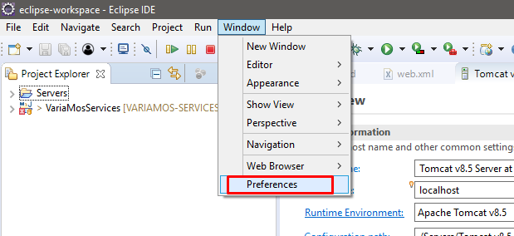

* Click in Preferences and search for “Java Compiler”
* Make sure your configuration looks like the following:

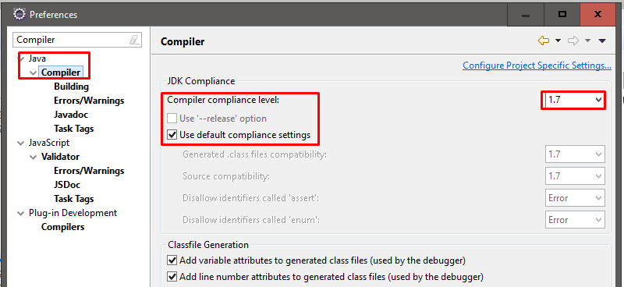

* Click in apply and close 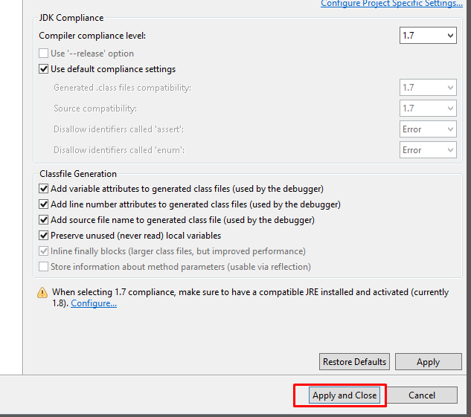
* If you have VariaMos-Services already running, you have to restart the server for changes.